**28.2 Neurons conduct nerve impulses.**

**Day One**

1. Read the first four pages of the PDF (stop when you see figure 28.6)
2. Complete the notes and questions using the PDF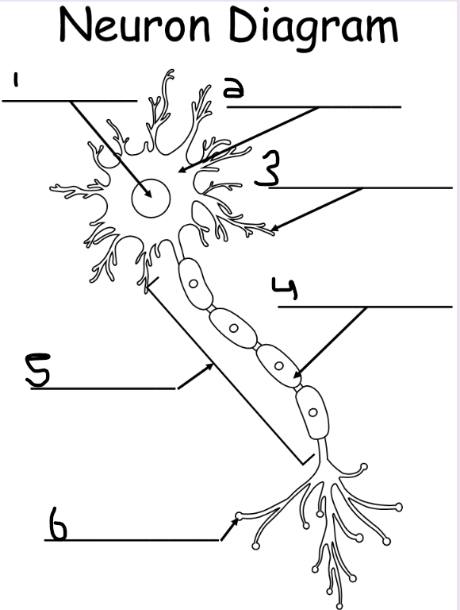
3. **Name and describe the parts of a motor neuron**

**Refer to the diagram on the right**

| **Part** | **Name** | **Function** |
| --- | --- | --- |
| 1 | Nucleus | It is a powerhouse and contains genetic material for the neuron. |
| 2 | Cell body | A typical neuron has a cell body that houses the neuron's nucleus and most of the organelles. |
| 3 | Dendrites | Receive signals and send them towards the neuron's cell body. |
| 4 | Myelin Sheath | The axons in which many neurons are insulated in a thick coat of material. |
| 5 | Axon | A fiber that carries electrical impulses away from the cell body and towards other cells. |
| 6 | Knobs | Transmitting messages to another neuron or cell. |

1. **Answer the following questions, bullet format is fine**

| **Question** | **Answer** |
| --- | --- |
| How is a resting neuron like a battery? | It's like a resting battery because electrical energy is being stored and waiting to be transferred ( stimulated ) |
| What ions are involved in creating the resting potential in the neuron? | Sodium Potassium. |
| What happens when a neuron is stimulated? | An electrical signal is sent through your body to your brain. |
| How fast can a nerve signal travel? | 5 meters a second but can travel faster with the Myelin Sheath. |

**Day Two**

1. Finish reading the 28.2 PDF
2. Use the reading to answer the following questions, bullet format is fine

| **Question** | **Answer** |
| --- | --- |
| What is a myelin sheath? | **A myelin sheath is an insulated coat of thick materials that insulate the neurons.** |
| How fast is a nerve signal on neurons with myelin sheaths? | **In a node with a myelin sheath, a nerve signal jumps node to node.** |
| What is a synapse? | **A synapse is the junction between knobs and another cell.** |
| What are the two types of synapses? | **Electrical synapse and chemical synapse.** |
| Where are you more likely to find electrical synapses? | **You are most likely to find electrical synapses in your heart and digestive organs.** |
| What is a neurotransmitter? | **A neurotransmitter is a chemical signal mostly consisting of small, nitrogen containing organic compounds.** |
| What are some examples of neurotransmitters? | **Examples of neurotransmitters are tiny vesicles or sacs.** |